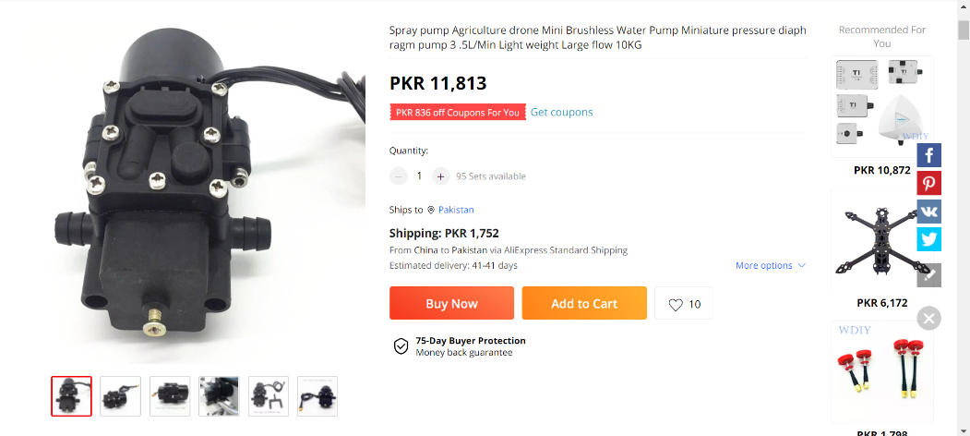For given spray zone, multiple spraying approaches were considered and as a result of detailed Mathematical calculation & optimization, following spraying mechanism is finalized for drone

12V brushless water pump of max speed 3.5L/min, 1MPa pressure & max power of 40W is used. This pump uses 5A ESC and it is specially designed for agriculture drones.

Brushless pump enables variable flow rate which makes spraying mechanism more efficient as explained in Control System part.

This drone uses nozzles of two types: Brass nozzles in front wings create fine spray with 0.5mm outlet. Nozzles in rear wing create atomized mist of pesticide using 0.1mm outlet for spray to reach all parts of plants. Plastic pipes of 5mm diameter connect pump to nozzles on both wings.

The concept of multiple nozzle diameters is introduced in latest DJI Agras drones as a step to improve spray efficiency in small fruit trees where larger droplets cannot penetrate.

Brass nozzles are used since they are long-lasting, lightweight and cheap.